Mission 2 — Earthworms for Soil Regeneration

1. What earthworms do in soil and why they are important
Earthworms are often described as “ecosystem engineers” because their activity changes the physical, chemical and biological properties of soil. By burrowing through soil, consuming organic matter and producing casts, earthworms influence soil structure, porosity, aeration, water movement, decomposition and nutrient cycling. A 2025 review describes earthworms as key organisms for soil health and highlights their effects on soil structure, nutrient cycling, water regimes, plant production and pollution remediation.
Earthworm-related process | What happens in soil | Potential relevance
Burrowing | Creates channels and pores in the soil | Better aeration, water infiltration and root growth
Organic matter decomposition | Earthworms consume and process organic material | Faster decomposition and nutrient release
Casting | Earthworms produce nutrient-rich casts | Increased nutrient availability
Nutrient cycling | Alters the movement and availability of nutrients | Improved soil fertility and plant nutrition
Microbial interactions | Earthworm activity changes the soil microbial environment | Increased biological activity and decomposition
Soil aggregation | Helps form and stabilize soil aggregates | Improved soil structure and resistance to degradation
Water regulation | Burrows modify water movement and retention | Better soil moisture dynamics
Pollutant interaction | Earthworms can accumulate and transform some contaminants | Potential use in bioremediation
Recent meta-analysis found that earthworms increased soil phosphorus availability by about 10%, plant phosphorus uptake by 21%, and plant biomass by 23%, although the effect depended on the ecological group of earthworm and soil conditions.
Overall: Earthworms function as natural biological engineers that continuously modify and improve important components of the soil ecosystem.
2. The Problem
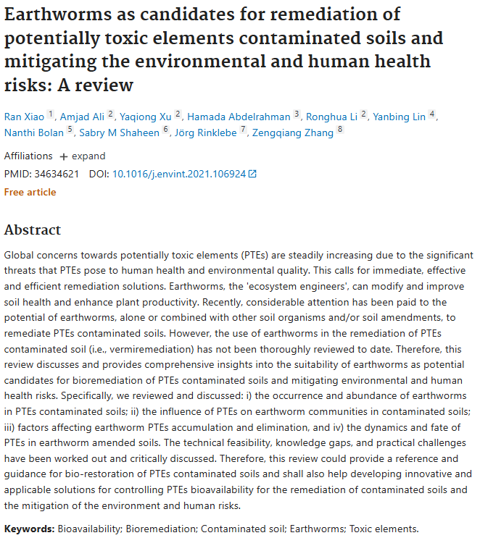
Overall: Soil degradation can reduce soil structure, water regulation, nutrient availability and biological activity, making the soil less capable of supporting healthy plant growth. At the same time, agricultural and industrial contamination can introduce potentially toxic elements and other pollutants that persist in soil and create environmental risks.
Traditional soil-restoration methods may require substantial physical, chemical or energy inputs. This creates a need for nature-based approaches that can simultaneously improve soil functioning and contribute to the remediation of degraded or contaminated soils.
Earthworms are already being investigated for this purpose. Research on vermiremediation has shown that earthworms can influence the mobility, accumulation and bioavailability of potentially toxic elements in contaminated soils. However, their effectiveness depends strongly on the contaminant, soil conditions and earthworm species, so they should be viewed as a potential biological remediation tool rather than a universal solution.
3. Proposed Solution — Earthworm as a Living Soil-Restoration System
Our mission proposes sending a living earthworm together with a controlled soil substrate to approximately 24 km altitude to investigate how exposure to stratospheric conditions affects the organism and its ability to perform its natural soil-engineering functions.
The earthworm will act as a living biological system rather than simply being transported as a biological sample. Its activity naturally combines physical modification of soil with decomposition, microbial interactions and nutrient cycling.
After the flight, the experimental soil will be compared with a ground-control system containing the same soil and earthworm under terrestrial conditions. A separate soil-only control can be used to distinguish changes caused by the earthworm from changes caused simply by the flight environment.
The experiment can evaluate measurable parameters such as:
earthworm survival and activity → soil structure → moisture → pH → nutrient availability → microbial activity
The central research question is:
Does exposure to stratospheric conditions affect the ability of a living earthworm to maintain its soil-engineering functions?
Rather than assuming that the flight will improve the earthworm's activity, the experiment will determine whether its biological functions are preserved, reduced or altered after exposure.
4. Relevance of This Idea
https://www.nasa.gov/science-research/nasa-plant-researchers-explore-question-of-deep-space-food-crops/
The importance of this mission extends beyond ordinary soil restoration. Future long-duration space exploration will require sustainable biological systems for plant cultivation, recycling of organic matter and maintenance of closed ecological systems. Space-based agriculture already relies on highly controlled growth systems because transporting all required resources from Earth is impractical for long missions.
Earthworms offer an interesting biological model because they naturally connect several processes necessary for a functioning terrestrial ecosystem:
organic matter → earthworm activity → soil structure + nutrient cycling → microorganisms → plant growth
If the earthworm maintains its biological activity after stratospheric exposure, this could provide a foundation for investigating biological soil-management systems under extreme environments.
In the longer term, this research could contribute to studies of sustainable soil restoration, vermiremediation and closed-loop biological systems for future controlled agriculture beyond Earth.
Mission Concept
Living earthworm + soil
↓
Stratospheric exposure (~24 km)
↓
Physiological response
↓
Earthworm–soil interactions
↓
Soil structure + nutrient cycling + microbial activity
↓
Assessment of biological soil-restoration potential

